Shabbos Stories for
Parshas shelach 5780
Volume 11, Issue 41 21 Iyar/ June 20, 2020
Printed L’illuy nishmas Nechama bas R’ Noach, a”h

For a free subscription, please forward your request to keren18@juno.com
Past stories can be found on the website ShabbosStories.com
Rebbe Shneur Zalman
And the Crazy Man
By Rabbi Tuvia Bolton

Here is a story that was told by the Lubavitcher Rebbe on Shabbat B'reshis 5735 (1975). (Ma Sh'siper li HaRebbe vol. 2 pg. 32)

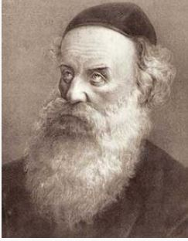
Rebbe Shneur Zalman of Liadi

Some two hundred fifty years ago in Russia, near the area where the first Rebbe of Chabad, Rebbe Shneur Zalman, lived, there was a crazy man. He had been a normal, sensible religious Jew with a wife and family until one day he suddenly lost his mind and began screaming and thrashing about for no apparent reason.
His family was shocked, his friends tried to help, his neighbors shook their heads in pity and the Rabbis prayed but it didn't help. So they collected money and went for professional help.
But the doctors also were at a loss and couldn't figure out what to do. They just scratched their heads and shrugged their shoulders and said that perhaps just it would go away as suddenly as it came. Or perhaps they had to be patient and gradually he would improve. But the years passed and he didn't.
To have him committed to an asylum was out of the question. There he would be treated like an animal and would be thrown together with dangerous maniacs.
Then someone suggested that they try the Rebbe of Chabad, Rebbe Shenur Zalman. So they bound him, got him into a carriage, and after several hours were in the town of Liazne entering the Rebbe's office.
In the presence of the Rebbe the madman was fairly still, once in a while giving a grunt or some other non-human sound and occasionally waving his hands but surprisingly when the Rebbe said he wanted to tell them a story and asked them to be seated he sat and they untied him.
The Rebbe began. "It says in the Talmud (Gittin 57b) that when Nebuchadnezzar conquered Israel and his troops entered the First Temple to destroy it they noticed there was a pool of blood bubbling on the floor of the Temple courtyard.
The commanding general then gathered the Cohanim (priests) and asked for an explanation and they explained that it was the blood of a little-known Jewish Prophet called Zechariah (not the famous one who lived years later in the beginning of the Second Temple)."
When he saw they were all listening, the Rebbe continued.
"Now please listen closely. The accepted story is that the Jews stoned him to death because he stood in the Temple courtyard and told them things they didn't want to hear; enumerating their sins and threatening them with death and exile if they didn't repent.
"But, in fact, that is not what happened. The story is quite different. The motive in killing him was much more positive."
The Rebbe looked at the crazy man and then at his family to make sure they were listening and continued.
"The fact is that only a few men stoned Zechariah and they were 'Tzadikim;; totally righteous Jews, perhaps the only Jews that had not sinned in those days. And they stoned him in order to save everyone else.
"So, in fact, he did not anger anyone he didn't even speak. As soon as he stood befsore the crowd these holy men understood what he was about to say.
"They knew that he was about to prophesize the destruction of the Temple and the exile of the Jews to Babylon. And they also knew that because his words were prophesy, as soon they would be uttered the decree would be sealed unless the Jews repented. But they were aware that the Jews weren't ready to change their ways.
"So they decided that they had to make the ultimate sacrifice even if it would cost them both this world and the next! They knew that by killing him they would die as sinners but so great was their brotherly love that they didn't care about themselves; only about stopping that prophesy and possibly averting the decree of death and destruction.
"But perhaps you will ask why didn't the prophet Zacharia himself refuse to make his prophesy? Certainly, he had no less love for his fellow Jews than those who killed him. Why didn't he just keep quiet?
"And if you try to explain that if he did so he would be punishable by death (which is the law regarding a prophet that refuses to prophesize). If so, then why didn't he give his life as those who killed him were willing to do?
"The answer is that a true prophet is nothing more than a conduit for G-d's messages and he knows that G-d is good. In other words, his entire essence exists only to give over his prophesy with no worry of its repercussions.
"But those who killed him did worry and they felt they had no choice but to make a desperate attempt to save the Jewish people from tragedy and exile. So they murdered him.
"Now, the tortured souls of those Tzadikim who murdered Zechariah have been in limbo for almost two and a half thousand years; They couldn't enter heaven because of their sin of murder. And the gates of hell also would not admit them because of their pure intentions. So they have been waiting to be corrected
"That is why you came to me." The Rebbe concluded.
"These souls entered your father's body and made him insane in the hope that someone could find some redeeming quality in their sin and free them. And that is what I did.
"When I learned "Zechut" (merit) on their deed I made a 'Tikun' (correction) on their souls and now both they and your father are released."
Suddenly the insane man closed his eyes briefly, smiled with relief and began to breathe easily. He was cured!!

Reprinted from the Parshat Behar-Bechukosai 5780 email of Yeshiva Ohr Tmimim in Kfar Chabad, Israel.

Regards from Dubai...

There’s an amazing story told in Rabbi David Ashear’s Daily Emuna book about a businessman who made a tremendous kiddush Hashem. Steve received an order about four years ago from a customer in Algeria for 10,000 pieces of Samsonite luggage. As a rule, Steve didn’t ship the goods until he received the full payment. A check arrived for $833,000. Steve deposited it and then called his customer from Algeria to arrange the shipment. The customer did not answer his phone. Steve continued trying by phone and email, but there was no response.
Finally, almost two weeks later, Steve received a phone call from the owner of a large chain store. He said that he was waiting to receive the luggage from Steve’s customer in Algeria, but unfortunately, the man had passed away suddenly. The owner asked if he could buy the luggage straight from Steve for the same price he was going to pay the man in Algeria, which was $900,000.
Steve said, “No problem.” And that’s exactly what happened. The owner of the chain store sent Steve $900,000, and Steve sent him the luggage. Now Steve had this extra $833,000 in his bank account — from the original customer in Algeria — that probably no one would ever find out about. He did not want to keep it, so he consulted with his Rabbi, who quoted the Shulhan Aruch and said, “This is a great opportunity to make a kiddush Hashem.”
Steve called the wife of his customer in Algeria, and told her that he had some money that belonged to her husband that he wanted to return. She thanked Steve for the news. Then, strangely, she then asked if they could continue their conversation on Skype, because even though Steve had called, she was being charged for the call. He gladly Skyped her. She saw him wearing a kippah and she said, “Oh, I see that you’re Jewish.”
He replied, “Yes, and I’m very happy to return this money to you.” When she heard it was $833,000, she couldn’t believe her ears, and thanked Steve profusely. Steve mailed her a check and thought that that was the end of the story. About a week and a half later, a stretch limousine pulled up in front of his office. A man came in and practically bowed down on the floor, kissing Steve’s feet. Steve asked, “What’s this all about?”
The man explained that he was from Dubai, and was the first cousin of the lady from Algeria. The man couldn’t believe that Steve had returned all that money. He said, “You’re an angel.” Then he said, “I’m a very wealthy businessman, and I have a lot of wealthy friends in Dubai. Because of your honesty, I want to open up a whole new world of business for you in Dubai.”
So over the last three to four years, Steve has been making many multi-million dollar sales to these people in Dubai that he never met before. He has earned far more than the $833,000 that he returned. Recently, he received an order from one of those customers for 11 million dollars. Steve received the check, cashed it, and called the customer to discuss the shipping arrangements. However, this time Steve asked him a question.
He said, “I hope you don’t mind me asking; I’m just curious to know. You have never seen me before and I live on the other side of the world. How can you just send me a check for $11 million trusting that I’ll send you the goods? I could just take the money and run.”
The man on the other line said, “If you didn’t take the money from a dead man, you’re not going to take the money from a live man!” Dozens of businessmen in Dubai sing the praises of the Jews because of Steve’s honesty. This is a real kiddush Hashem, and Steve has gained both in this world and the next.

Reprinted from the Parshat Emor 5780 email of Rabbi Amram Sananes as written by Jack E. Rahmey.

Consider a story which happened on the bus on Rechov Sorotzkin in Eretz Yisrael. Many schoolchildren got on the bus and were standing at the front to get their tickets punched. As each child’s ticket was punched, he moved to the back of the bus. One child was standing there, and the bus driver said, “Move! Go to the back!” The child said, “No, I can’t.” the bus driver then said, “Why not?”
The child explained, “Because you didn’t punch my ticket.”
The driver said, “Yes, I did.”
The boy said, “No, you did not.”
The driver angrily repeated, “Move!” and he reluctantly went to the back of the bus.
A few moments later, the bus driver looked into the mirror and he saw the young boy crying in the back of the bus.
The drivser stopped the bus, walked to the back and he asked the child, “What’s wrong?”
The boy said, “This is forbidden. This is theft. I can’t ride the bus. It’s stealing.” And he held out his card. The bus driver punched the card again and patted the boy on the head. This little seven-year-old, unbeknownst to him, did such a beautiful act of kiddush Hashem.

Reprinted from the Parshat Emor 5780 email of Rabbi Amram Sananes as written by Jack E. Rahmey.

Rav Yaakov’s First
Entrance Exam

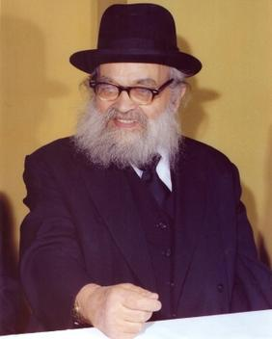

After little Yaakov Kamenetsky was born, his family moved to a small town by the name of Dolhinov, where the people of the village had an unquenchable love for Torah.
As a young child, his father would take him on Shabbos night at two in the morning to the Beis HaMedrash which was filled with the sounds of Torah learning, as if it was in the middle of the day.
At the age of eleven, the young Rav Yaakov Kamenetsky left home to learn in the Yeshivah of Minsk, where he passed an entry exam with the Rosh Yeshivah, Rav Shlomo Glovenchitz, zt”l, displaying his brilliance in learning.
The Rosh Yeshivah, however, was still unsure whether he should accept such a young boy into the Yeshivah, and told him: “You are not even Bar Mitzvah yet.”
With the innocence of a child, the young Rav Yaakov replied, “Well, I came here to learn, not to be the tenth man of a Minyan.”
Rav Yaakov was accepted into the Yeshivah, and made his way to become one of the greatest Torah giants of his generation!

Reprinted from the Parshas Behar-Bechukosai 5780 email of Torah U’Tefilah as compiled by Rabbi Yehuda Winzelberg.

For the Sake of
That “Hour or Two”
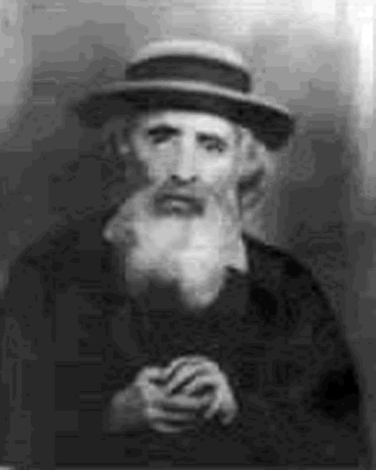
Rabbi Yehoshua Leib Diskin

Rav Yehoshua Leib Diskin, zt”l, would occasionally go visit an elderly relative with his Gabbai. The relative was bed-ridden, and always looked forward to her visitors. When they arrived, they couldn't help but notice how poorly lit the apartment was, and how dirty and odorous the rooms were.
As usual, Rav Yehoshua Leib asked if there was anything he could do to help. Although the sick relative never allowed him to help, she replied that this time she had a request.
"Please Daven for me that I merit to live a long life!"
The Gabbai was shocked at her words, thinking of the poor quality in which she lived, and wondered why it was so important for her to cling to life?
The woman, noticing the Gabbai's reaction, explained herself to him and said, "You must be wondering why I want to live many more years in such conditions."
She continued, "Once every two weeks, a nurse comes to bathe me and clean my room, and for an hour or two after that, it remains fit for me to say Brachos to my Creator. There is a Shul across the street and I am able to open my windows and respond ‘Amein’ and ‘Yehei Sh’mei Rabbah’ to the Tefilos. It is my hope to live for many years to come so that I can continue Davening and answering ‘Amein', even if it is only once every two weeks!" Rav Yehoshua Leib was so impressed by her words that he repeated them to others many times!

Reprinted from the Parshas Behar-Bechukosai 5780 email of Torah U’Tefilah as compiled by Rabbi Yehuda Winzelberg.

The Synagogue with
An Eerie Sound
By Rabbi Eli Hecht

When entering the prayer room, you
would hear a continuous sobbing sound

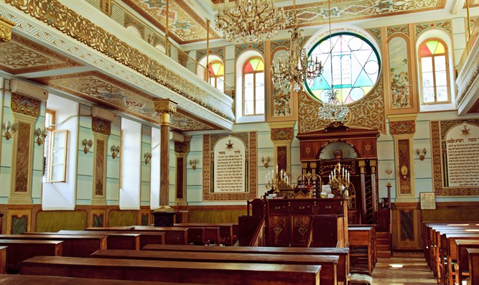

A story is told of an ancient house of prayer in Europe that possessed an eerie sound. When entering the prayer room, you would hear a continuous sobbing sound. The closer one would walk to the ark, the stronger the sobbing was heard. The old caretaker, the shamash, would tell of a story he had heard from the older shamash relating to the phenomenon dating back hundreds of years:
There lived a saintly man, a tzaddik, who prayed and fasted all his life. The saint was as close to an angel as possible. One night while in deep prayer, he heard G-d’s voice calling to him.: “My son, tell Me what you need and I will grant it."
The saintly man thought and thought. I have clothing to wear, my health is good and I have a place to pray. I don't need money. "Nothing dear G-d", the saintly man answered.
There was silence and then a loud sob. Thunder and lightening filled the air. G-d's voice thundered out.: “Why did you think of yourself, you should have thought of Me. How I suffer for My people, for mankind, and justice for the poor and needy. Why did you not think of my suffering? Why did you not ask that my suffering cease?"
The saintly man realized his sin and was too troubled to speak. From then on he grew weaker and weaker. On his deathbed he told his most trusted students his tragic story.
From that day on, when entering the prayer room you could hear the sobbing, as if the prayer room was crying for G-d's suffering, for the lost opportunity.
Pray for an end of suffering: your suffering, my suffering and, most of all, G-d's suffering.

Reprinted from the May 31, 2020 email of Arutz Sheva. Rav Eli Hecht is Director and Founder of Chabad of South Bay, Lomita California, former President Rabbinical Council of California, and Vice President of the Rabbinical Alliance of America.

Arab Praises Haredi
Jew as “a Holy Man”
By Michal Levi

Yosef Chaim Machlouf, a Haredi (ultra-Orthodox) religious Israeli from the Givat Ze'ev area, noticed a bag on the road in the neighborhood a few days ago.
Picking up the bag, he discovered 40,000 shekel ($11,347), along with checks for more. Later, it turned out that the bag belonged from an Arab residing in the Jerusalem neighborhood of Gilo.
In an interview with Kol Hai Radio, Machlouf said, "According to Jewish law, not only did I not have to return the bag, it was even forbidden to return the bag, unless doing so would sanctify G-d's Name, and then it would be permissible. So I returned it."
"Because of the situation with coronavirus, I decided to go above and beyond, and I asked G-d to act the same way with us."
During the interview, the Arab who lost the bag came on air and said, "In every place, there are good people and not good people. I am happy I ended up, thank G-d, with someone good, who returned the money to me, and I thank him very much. He's a holy man."

Reprinted from the May 25, 2020 email of Arutz Sheva

The Minchas Yitzchak’s Miracle Son

Reb Yaakov Yitzchak Weiss zt’l (the Rav of Yerushalayim, author of Minchas Yitzchak) was married three times. This is his inspirational story, which he himself related: A shidduch was suggested for him. The girl lived far away, and it was hard for his parents to travel there, so they sent a shaliach to check out the girl and her family, to determine whether the girl was a fitting match for their son. The shaliach returned and said that it was a fine match and Reb Yaakov Yitzchak was engaged. The Weiss's traveled to the kallah's hometown for the chasunah. That was the first time Reb Yaakov Yitzchak’s mother saw the kallah, and she was very disappointed. It wasn’t a proper match for her son at all. She wanted to terminate the shidduch.
According to halachah it was permissible to do so (because the shaliach was sent to make an appropriate shidduch, which this wasn't) but Reb Yaakov Yitzchak said, "Perhaps with time I will divorce her. But right now, I don’t want to embarrass her."
They were married and had one son, Reb Berish. His wife was killed during war. At his second marriage, Reb Yaakov Yitzchak remarried to the daughter of the Rav of Vasloy zy’a. Later, he married the daughter of the Imrei Chaim of Viznitz zy’a, but he didn’t have children from either of them.
His only child is Reb Berish, born to the woman he didn’t want to shame. Reb Yaakov Yitzchak testified, "Doctors told me that it was impossible for me to bear children. Berish was a miracle. I am certain that I merited this child as a reward for not embarrassing a Jewish girl."

Reprinted from the Parshas Bamdibar 5780 email of Torah Wellsprings: Collected Thoughts from Rabbi Elimelech Biderman.

Singing with Gratitude
By Rabbi Menachem Salasnik

‘Shetilei Zeitim’ is a well known and well established shul in Bnei Brak. The vasikin minyan had been led daily by Rabbi Ezra Mizrachi for more than two decades, without any change in the style of service.
But then, one day four years ago, R’ Ezra did something different; when he got to the psalm of Mizmor L’Soda – Song of Thanks, instead of saying it quietly to himself as per usual, he sang it out loud to an upbeat tune.

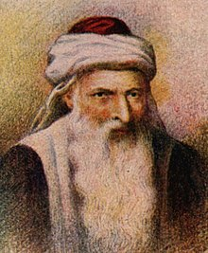
Artistic conception of Rabbi Caro's appearane

The regulars crowded round him at the end of the service, itching with curiosity to find out the reason for the change. R’ Ezra explained: “Yesterday I came across a little-known Halacha in the Shulchan Aruch where we are instructed to sing this. We are being told that, instead of saying it without any special emphasis (or possibly even without any thought at all), we should make it significant: with a tune that truly expresses our deepest gratitude to our Creator.” “What do you think?” he asked the congregants. “Should we make this upgrade a daily occurrence?”
After they had been reassured that he would use a swift upbeat tune and the service would only be lengthened by a minute, they agreed. And so it was, every day R’ Ezra sang the song and everyone joined in with joy.
About a year later, R’ Ezra started experiencing severe pains which his family doctor could not explain. He was referred on to a specialist who carried out a full battery of tests. When he was invited back to the clinic a few days later for the results he saw that the consultant had a serious look on his face.
He said, “I have been a doctor for many years and I still don’t know how to deliver difficult news to my patients. While the results are not 100% conclusive and we will have to do further, more intensive tests in a few weeks, nevertheless I would recommend that you prepare yourself. We live in a time where there are many excellent treatments but you should be prepared for a lengthy and difficult period ahead.”
There was silence in the room while R’ Ezra digested the information. While the doctor had left the diagnosis unspoken, it was clear what he was hinting at. However, he quickly pulled himself together and offered a silent prayer with deep faith: “My life until now has been wonderful! Thank you Hashem! I trust in You that just as up until now my life was happy and beautiful, so, if You choose, You can continue to give me many more years of happiness to come!”
As he left the consulting room, without knowing why, he found himself humming the tune to Mizmor L’Soda. Three weeks passed and the day preceding his recall arrived. As he was singing Mizmor L’Soda that morning, he had a sudden thought. As soon as prayers were over, he rushed home, discussed it with his wife and then went straight to the bus stop to head to Tzfat, where he planned to pray at the grave of Rabbi Yosef Caro, author of the Shulchan Aruch.
When he arrived at the gravesite, he suddenly found himself crying uncontrollably. He started to pray from the depths of his heart. He thanked Hashem for all the good years he had been gifted, his family, health, livelihood. And then he begged that he should be healthy, that his children should have a healthy father. And finally he cried out, ‘Rabbi Yosef! You wrote the Shulchan Aruch for us, filled with laws of daily living. But there is one that is not so well known - to sing Mizmor L’Soda in public - which I have been careful to keep over the last year, so that I can thank Hashem in the appropriate way. I am in a desperate situation!
“Please plead my case before Hashem and be a meilitz yosher (a positive advocate) on my behalf, so that Hashem in His kindness will arrange for me to go through the tests tomorrow peacefully. May there be no growth or sickness, no worry or suffering; just health, calm and joy so that I can continue to demonstrate my gratitude!”
And then, after reciting a few chapters of Tehillim, he sang Mizmor L’Soda with real feeling. The next day, throughout the many tiring examinations, R’ Ezra maintained his gratitude and trust in Hashem. When he was finally called into the specialist’s office, he was surprised to see the doctor confused, with shock and disbelief etched on his face.
“Listen,” he said. “In all my medical career I don’t remember a more astonishing situation!” Pointing to the scans, he explained, “This is the scan from three weeks ago, you can clearly see the growth. But this is today’s scan, there is nothing there, not even a tiny remnant. Even the blood tests today were normal! It’s unbelievable!” The doctor carried on speaking but R’ Ezra wasn’t really taking it in – he was already humming the tune.

Reprinted from the Parshat Bamidbar 5780 email of Oneg Shabbos (London, U.K.)

Story #1152
Seventy-Fours
From the Desk of Yerachmiel Tilles
editor@ascentofsafed.com

Towards the end of his life, in 1850, Rebbe Moshe of Lelov traveled to the Holy Land, arriving shortly after the Sukkot festival that year. He said that if he prays at the Kotel HaMaravi (Western Wall) [and blows the shofar there], it will hasten the Ingathering of the Exiles and the Coming of Moshiach.
Before he began his journey, he went to take leave from several of the major Chasidic leaders of his generation. When he came to Rebbe Yisrael of Ruzhin, the Rebbe said, "Wait for me. I want to go with you."
R. Moshe pointed to his white beard, implying that he was getting older and didn’t have time to wait.
His plan was to travel with a group of ten people. He put away money for this cause, but whenever he had enough money he ended up giving it to tzedakah, and then he would have to start saving money for the trip again.
Once, a childless woman came to Rebbe Moshe, and requested a blessing for children. He told her that if she gives him a certain large amount of money (the amount he needed for his trip) she would have a child. She was ready to give the money, but R. Moshe told her that she must ask permission from her husband first. Her husband was a chasid of [Rabbi David-Zvi-Hersz Taub,]"the Gitte Yid" [tzadik] of Neustadt, and he asked his Rebbe whether to give the money.
The Rebbe replied, "You should give the money. However, since you need a miracle to bear a child, I recommend that you tell Rebbe Moshe of Lelov that you will only give the money if the Rebbe promises that the child will live long. Because when a child is born with a miracle, he often doesn’t live long."
When she returned with the money, she stipulated the condition. Rebbe Moshe Lelover replied, "The years of your child's life will be as many as the days I live in Eretz Yisrael." R. Moshe lived seventy-four days in Israel, and the child lived for seventy-four years.
[The Rebbe of Ruzhin said that if the Jews in Poland were wise, they wouldn’t have permitted such a great Rebbe to depart from them. He provided an allusion to this from a Mishnah in Shabbos, “Ain polin l’ohr haNer"/Do not distinguish by the light of the [Shabbat] candle, which he rendered homiletically as, ‘The Polish (Jews aren't wise; they had but) let leave their one brilliant light."
When Rebbe Moshe was on the boat, he kept repeating, "yom leshanah “a day for a year." People didn’t understand his intention. Later they realized that he was praying to live one day for each year of his life. He was seventy-four years old then, and he lived in The Land a corresponding seventy-four days.

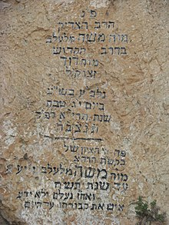
Tombstone of Rabbi Moshe of Lelov

Many wondrous stories are told about his voyage. One * is that there was a hole in the boat and water began to seep in! Rebbe Moshe placed a cloth over the hole, and this miraculously stopped the influx of water. (This cloth is still extant, and is used as a bedecken tichel (wedding veil) by the kallahs (brides) of his descendants.)
Rebbe Moshe took with him his son Rav Eliezer-Menachem-Mendel (Rav Luzer Mendel), and his six-year-old grandson David-Tzvi-Shlomo (Reb Dovidl). The ship docked in the northern port of Acco. Rebbe Moshe travelled [by donkey!] to visit the tzaddikim who lived in Tsfat and Teveriya (Safed & Tiberias) and other holy burial sites in the area before going up to Yerushalayim (Jerusalem), because he said that after he gets to Yerushalayim, he will not want to leave.
When he finally came to the Old-city of Jerusalem, he was ill. His children debated whether they should bring him to the Kotel in this condition. They decided that since his primary purpose for coming to Israel was to go to the Kotel to hasten bringing Moshiach, they should. But as they were bringing him towards the Kotel, Arabs blocked their way and threw rocks at them until it was impossible to continue. The family and the chasidim who accompanied them sadly returned to their rented lodgings.
Unfortunately, he never reached the Kotel. [Broken hearted, feeling that the window of opportunity for Redemption had now been slammed shut, he became extremely ill and passed away three days later.] On the seventy-fourth day of his arrival to the Holy Land, on the thirteenth of the Jewish month of Tevet, his soul departed from its bodily restraints.
He promised amazing things about his yahrtzeit. He said that the date of his demise is propitious for rain, and therefore even in a year that is lacking rain, it is unnecessary to proclaim a fast day to pray intensely for rain before his yahrtzeit passes. Rav Shmuel Salant, the chief rabbi of Jerusalem heeded his words, and for the next half century until his own passing refused to decree a fast day for rains until the thirteenth of Tevet passed.
R. Moshe also said that those who will dedicate a meal on his yahrtzeit in his honor (even if it is just cake and l’chaim,) will have a salvation for whatever they need.
Source: Adapted and supplemented by Yerachmiel Tilles from “Torah Wellsprings” (gleanings from the teachings of Rabbi Elimelech Biderman of Jerusalem - Vayechi 5777), as translated by R. Baruch Twersky. Square-bracketed [ ] insertions are from //littmann613.blogspot.com/2012/08/the-dynasty-of-lelov.html.
Biographical notes: Rabbi Moshe Biederman of Lelov [? - 13 Tevet 5611 (1850)] was the son of R. David, the first Rebbe of Lelov, and the son-in-law of "the Holy Yid " of Peshis’cha (having married his daughter, Rivka-Rachel). Although he declined to officially succeed his father, considering himself unworthy of the position, the chasidim nevertheless accepted and followed him as Rebbe over his protests. In 1850, he moved to Israel, and settled in Jerusalem, where he passed away 2 ½ months after his arrival. He was succeeded by his son, R. Eliezer Menachem Mendel, and after him by his grandson, R. David Tzvi Shlomo. The three are buried on the Mount of Olives, near the prophet Zacharia, although the exact location of R. Moshe’s grave is not known.

Reprinted from the Parshat Vayechi 5780 email of KabbalaOnline.org, a project of Ascent of Safed.

